General Information’s

Mays Khalid Mahmoud Alkaissi

Phone: +971555652060
Email: mkkaissi@hotmail.com
Address: Ajman city – Aljurf area
Sex: female
Date of birth: 09l 10 l1989
Nationality: Iraqi
Marital stat: married
Visa: Resident on Husband
Occupation: Dentist

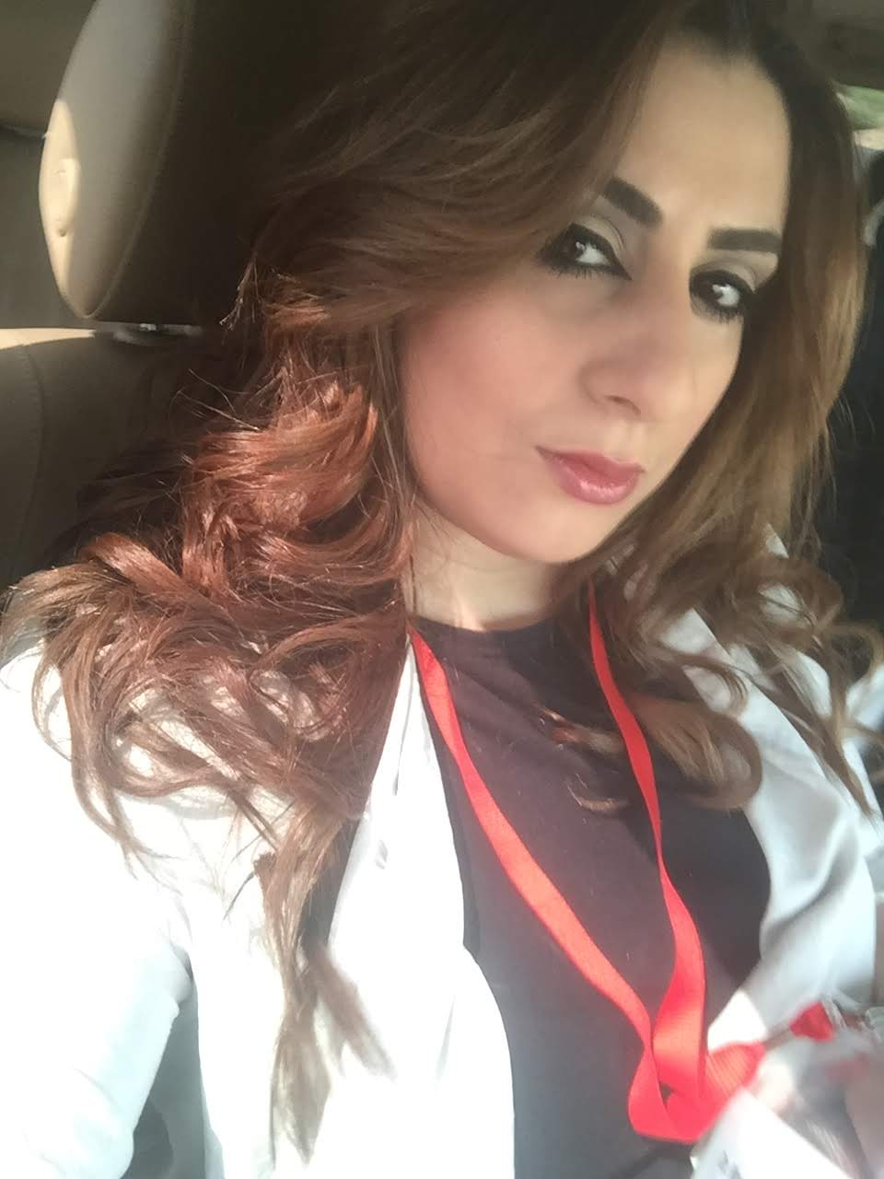

Objective | Ambitious newly qualified Dentist with excellent organizational and interpersonal skills, keen to secure a position with a dynamic and progressive dental practice. Ideal candidate for position requiring drive, initiative, responsibility and challenge.
Education | - Doctor of Dental Surgery (DDS) Ajman University 2008-2016.  - International member of American Dental Association (ADA).  - Internship training program 2018-2019.  Projects :  -Contribution and participation to Eighth Student Scientific conference research paper (pregnancy and oral health).  (This project was submitted in the form of a 2,000 word essay and presentation).  - Graduation project grade : very good  - 60 hours CE , online education and conferences  Clinical Training :  - Al – sharq hospital – emergency ,Operation Room , intensive care unit , radiology and genecology rotational training and seminars for one month – ALFUJAIRAH 2016.  - Ajman university clinical rotation and emergency dental care for 5 months 2016.  - Ajman university internship program for one calendar year 2018-2019.
Experience | - Assigned quota of dental requirements to be completed over one year period which included all aspects of restorative dentistry.  - Contacted patients on university dental clinic waiting list for dental treatment by appointment card or by phone.  - preformed clinical assessment on patients – discussed treatment options and decided best treatment plan taking into account factors including time, age, medical and dental history of patient.  - Preformed weekly pediatric, surgical, periodontal, prosthodontics and endodontic procedures on adult patients and children.  - Developed excellent communicational and patient care skills.
Responsibilities | - Responsible for obtaining information in a respectful manner in order to determine an appropriate treatment plan.  - Preform examinations and treatment quickly, efficiently and accurately while keeping the patient informed and being sensitive to patient comfort during the treatment.  - Set the expectation with the patient by listening to their concerns and addressing those that can be addressed and informing the patient of the course of action to follow the other health concerns.  - Communicate effectively with dental staff, other health care providers and patients.  - Ensure that verbal and written instructions are clear and concise and are understood by listening and speaking for feedback.  - Work in coordination clinical stuff and dental specialists to effectively educate the patient on their course of treatment in order to increase the like hood of compliance.

Language  & computer skills | language :  - Arabic : mother language  - English : excellent  Computer skills:  - Very good in using Microsoft office application (word, power point, excel, photo manger), mailing, searching and social media interacting.

